Ordering and Delivery Tracker App for Quadro King Water Station Retail Store

A Capstone Project Presented to the Faculty of the
College of Computer Studies
AMA Computer College – Las Piñas Campus

In Partial Fulfillment for the Requirements of the Degree of
Bachelor of Science in Information Technology (BSIT)

Marlo, Dael
Alegrid, Floren Joseph A.
Belbis, Luis Gabriel O.

February 2021

ACKNOWLEDGEMENT

The authors would like to express their profound and sincerest gratitude to the following individuals who helped in successfully accomplishing this study:

First and foremost, to Prof. Karren de Lara the group’s academic adviser, for the time, patience, support and guidance to the researchers despite the busy schedule and never failing to accommodate and guide them all throughout the study.

To the researchers’ parents for providing them unfailing support and continuous encouragement throughout the months of the study and through the process of researching and writing this study. For serving as an inspiration and became the fuel to keep the researchers from moving forward.

The Researchers

ABSTRACT

TABLE OF CONTENTS
Title Page
Approval Sheet
Acknowledgements
Abstract
List of tables
List of Figures
List of Appendices
List of abbreviations and symbols
Definition of terms
CHAPTER I: PROJECT AND ITS BACKGROUND
Project Context
Purpose and Description
Objective of the study
Significance of the study
Scope and limitation

CHAPTER II: Related Literature
Foreign Literature
Local Literature
Foreign Studies
Local Studies
Synthesis
Technical Background
CHAPTER III: METHODOLOGY RESULTS AND DISCUSSIONS
Software Design, Products, and/or Processes
System Architecture
Conceptual Design
Cost Benefit Analysis
Requirement Analysis
System Architecture / System Flow
Block Diagrams
Development and Testing
Input and Output Reports Analysis
Description of Prototype
Implementation Plan
Implementation Results

DISCLAIMER
The study has been made the product of hard work of the researchers. It has been approved and accepted by the panel of reviewers. Hence, no part of this paper maybe used without proper citation or approval from the authors.

Chapter 1
PROJECT AND ITS BACKGROUND

Project Context
Nowadays, people lean on online deliveries for their essential needs like food, groceries, and etc. The Ordering and Delivery Tracker App will innovate the services of water delivery businesses and also their management of it. The goal of the researchers is to make an application that will help the management of the orders, and to track the delivery riders, also to track the address of the customers using Global Positioning System (GPS).
An online system will always ensure that a role is/are carried out to achieve a precise outcome. Customers or clients will receive the same level of service. The system will be able to manage employees, and tasks more effectively.
Because of the many advantages and benefits of an online system, more people are saying that they prefer to buy their needs online. Buyers conduct their own research on a certain product to see if the said product that they will buy will be okay to use. The internet makes doing business a lot faster and easier. It has led to changes in the way people do business with a rapidly growing world-wide trend towards online shopping or e-commerce.
Bottled water is drinking water packaged in plastic bottles we call them as a “Big Blue Jug”, “Mineral water Gallon”. It is commonly sold in blue and may range from large serving container to the smallest size of bottled water. The Mineral water, drinking water, Water Station industry in the Philippines made its popularity in the early 2000s because there was a period were Filipinos find it difficult to access safe drinking water. This scarcity made businessmen invest for drinking water refilling establishment and has been seen as the main source of clean and safe drinking water. But most of these businessmen didn’t invest for tech solutions such as online transaction because doing transactions offline are far more accessible to them and they would think investing in such tech solutions would cause wasted resources since people are used in our current ordering system. The major disadvantages of this offline system are repeated calls from the customer and to customer, if multiple orders are placed at the same area the delivery person has to travel multiple times, and there is no order tracing and there is a direct contact from delivery person to customer. Customers’ are also at risk of infection if they have to go outside of their homes to order water containers. In this current system may help contribute the spread of deadly COVID-19 as we are practicing social distancing. This paper proposes an android application for water vendors (Quadro King as the main beneficiary), delivery person and for the customer. Customers’ can make order over the application for water container ordering and can search for the nearest water station in their locality which provides online transaction and make payment online. The delivery person will be able to track the customers’ exact location and find the best and efficient route of delivery and shopkeepers will be able to showcase their water products over the android application. This study looks at the current ordering system showed a lot of disadvantages. First is in placing an order, the customer has to call the water station’s landline number. In most of household don’t own landline number so some of them needed to drive down to the shop to order water. Texting or DM’s to the shopkeeper. Second is placing an order over the phone lacks visual confirmation that the order was placed correctly. Third is every Water Station needs a certain person to take order over the phone or walk-in, to offer a customer satisfaction and process the payment. Walk-in orders could increase the possibility of transferring deadly COVID-19 virus. Last is there are no ways to boost the sales of the shop without a product showcase online.

Online systems are accessible from any computer or smartphones as long as they are connected to the internet. Users can manage their businesses anywhere. Online systems are another version of information system, which is the process of tools for storing, using, managing, and gathering of data and communications in an organization. Online platforms have innovated the access to all information. In our everyday lives, we use the internet to access different kinds of information and data that we search upon. We also use the internet to shop, and communicate with others.
There are various types of systems, they are transaction processing systems, decision support systems, knowledge management system, and learning management systems. Transaction processing system is a set of information that processes the data transaction in a database system that monitors transaction programs used. A decision support system is a computerized program use to support determinations, judgements, and courses of actions in a company, organization, or a business. Knowledge management system is any kind of IT system that retrieves and stores knowledge to improve understanding, collaboration, and process alignment. Learning management system is a software application for the documentation, administration, reporting, tracking, automation and delivery of educational courses. Database management system is a software package designed to define, manipulate, retrieve and manage data in a database.
Office information systems uses a software, hardware and networks to improve work flow and help communications among employees.
Purpose and Description
The popularity of online shopping here in the Philippines has been proven to ease our hectic daily lives. Today, most of the customers don’t need to drive to the shops of Divisoria or Malls for buying products but preferably they check over the mobile app for prices, offers reviews and order online. In Metro Manila, water containers are purchased from the water vendors for their needs for the day. The current system working in Metro Manila is where the customer calls or go to the shop to order the water container by providing the shopkeeper their address and then a delivery person delivers the order to the customer’s house. This current system has a lot of disadvantages. The major disadvantages of this offline system are repeated calls from the customer and to customer, if multiple orders are placed at the same area the delivery person has to travel multiple times, and there is no order tracing and there is a direct contact from delivery person to customer. Customers’ are also at risk of infection if they have to go outside of their homes to order water containers.
The proposed system although its main purpose is to provide tracker and ordering tracking system it does not disregard the customer security aspects. The system will ensure that the customers information as well as other user of this system are safe and will also ensure that this information will not be leaked in the internet. Account information such as address, name, and contact information is securely stored in our databases using Firebase authentication services. The proponents will be also be using firebase’ s open source and scalable feature Firebase Analytics this module will provide usage reports of the app and the connectivity of all users. Tracker modules in this system are built in Android studio and this will be supported using Google Map Services. Essentially, the app is defined to provide navigation for the delivery person and on-the-map order tracker for the customer. This module is designed for the customer. Customer app, the customer has to provide their details upon signing up. Details like Name, Phone Number, Email Address(user-id) and password. The password can be changed by the customer anytime. The proposed app has to provide GUI in the app for Profile, Search Store, Place Order, Track Order, Cancel order. The administrator app, this component is designed for the developers. This will provide all authorities concerned to admin. Username and password is provided to this app by all of the users. This app will keep track of users like, Customer, Delivery Personnel and Store Owner.
Store Owner app, this app is for shopkeeper or store owner who provides water container for the customers. This owner has to provide details like name of the shop, owner’s name, water station address, phone number and email address to register for the username and password. Delivery Personnel’s App this app has one special feature which help the driver to deliver the product efficiently. The features provided are: orders, Routes, Status of the order, payment (COD).

Objectives of the Study
The main objectives of this study is to innovate the methods in ordering clean drinking water and also to innovate the process of managing the water station.
- To provide tech solutions for Quadro King Water station for their business
- To provide ease in ordering drinking water without the customer having to drive down to the shop to order water
- To provide the Delivery Person a In-app Map Navigation of the customers exact location and to provide efficient routes.
- To know the advantages of having this app in Water refilling business with the new and improved monitoring and online transactions
- To lessen the paper works in the environment by using the app as the monitoring peripheral.

Significance of the Study
The beneficiaries of the proposed system are the owner, employees and clients/customers of Quadro King Water Station, aims to cater to people easily using a mobile application. In order to make orders without the aim of going outside of their houses, or calling the water station, the customers will only need to download the application and register an account to be able to place orders like any other online delivery services.
Customers - once they already have an account for the delivery application, it will only take them a few clicks to have their orders placed, their address is already saved and once the moderator of the application confirms the order, they will proceed to prepare and deliver the order.
Owners - Owners of different water station businesses will also be able to use this application to improve their businesses. It will improve the way of transacting with customers.
The proponents - this application will be a stepping stone for the start of their IT careers. The aim for this research is not just to innovate the water delivery service, but also to showcase their skills and to learn from different people, and the opinions of others.
In the completion of this project the proponents is expected to learn and improved a lot in coding and programming in android, java, and kotlin. And they can also improve their skills in integrating app services like Google Map and Firebase utilities.

Scope and Limitation
This system provides four (4) components of application which are the customers app, Admin app for maintenance, Store Owner of the water station (Quadro King) and delivery personnel app. The system will provide user-friendly graphical user interfaces and data flow to all of the components.
Customer App
This module is designed for the customer. The customer has to provide their details upon signing up. Details like Name, Phone Number, Email Address(user-id) and password. The password can be changed by the customer anytime. The proposed app has to provide GUI in the app for Profile, Search Store, Place Order, Track Order, Cancel order.
Admin
This component is designed for the developers. This will provide all authorities concerned to admin. Username and password is provided to this app by all of the users. This app will keep track of users like, Customer, Delivery Personnel and Store Owner.
Store Owner’s App
This app is for shopkeeper or store owner who provides water container for the customers. This owner has to provide details like name of the shop, owner’s name, water station address, phone number and email address to register for the username and password.
Delivery Personnel’s App
This app has one special feature which help the driver to deliver the product efficiently. The features provided are: orders, Routes, Status of the order, payment (COD).
In general, the study focuses on the innovation of the water delivery services. Instead of relying on calls or text messages, the app will provide a new approach for them. The fast growing of the online delivery services will also affect the water delivery business for a better experience for both the owner and the customers. The current working strategy of the water station owners are old-fashioned and there is no use of technologies like internet, android and digital currency. It can be concluded that the proposed application will be effective in terms of providing solution to the current working method. This application provides a customer an android app where he can place water order and also track orders. It also helps the water station owner to maintain records oh their customers systematically and reduces a lot of paper works. This application will provide advantages like Water Station locator, customer satisfaction interfaces(in-app), order process estimate time of delivery. However due to time constraints this will app will not be able to feature online transactions using credit and/or debit card options for time being since the current system of acquiring API for an Android system may take a few months before the other banks who have technologies to accept payment online. This app will not cover Human Resources Management systems such as Employee application, Rider and Shop Personnel timekeeping and any related to Customer Service System.

Although the research reached its aims, there were some unavoidable limitations. For now, the proposed system will focus on the specific areas such as: Pilar Village, Almanza Uno, and TS Cruz village which are all located in Las Piñas City.
The tracker app will not be available in iOs.
The application will only run-on Android devices with android version Kitkat or higher version.
Chapter 2
Related Literature
Foreign Literature
Global Positioning System
GPS is the acronym for Global Positioning System. This technology allows a person to track where they are in the world through the use of mobile phones or laptop and computer with GPS receiver. This helps us locate where we are currently or find the place, cars also have this and gives us the best direction to the location we want to go. GPS is made with three (3) different parts, they are called segments and they work together to accurately show where you are. First is space they use specific satellites circling the Earth, sending signals to users on geographical position and time of day. Second is ground control ground control is Earth based monitoring stations. Control activities include tracking and operating the satellites in space and monitoring transmissions. There are monitoring stations on almost every continent in the world, including North and South America, Africa, Europe, Asia and Australia. And lastly user equipment devices with GPS receivers like smartphones, smart watches and even cars.
According to John Kyes (2020) GPS works through a technique called trilateration. Used to calculate location, velocity and elevation, trilateration collects signals from satellites to output location information. It is often mistaken for triangulation, which is used to measure angles, not distances. Satellites orbiting the earth send signals to be read and interpreted by a GPS device, situated on or near the earth’s surface. To calculate location, a GPS device must be able to read the signal from at least four satellites. Each satellite in the network circles the earth twice a day, and each satellite sends a unique signal, orbital parameters and time. At any given moment, a GPS device can read the signals from six or more satellites.
A single satellite transmits a microwave signal that is picked up by a GPS system and used to measure the distance from the GPS device to the satellite. Although a GPS system only contains information about the distance from a satellite, a single satellite cannot offer a vast volume of location information. Satellites do not have angle detail, so the location of the GPS system could be anywhere on the top of a sphere.
As a satellite sends a signal, it produces a loop with a radius measured from the GPS system to the satellite. When we add a second satellite, a second circle is formed, and the position is narrowed down to one of the two points where the circles converge. With the third satellite, the position of the device will actually be determined, since the device is at the junction of all three rings. Ok, being said, we reside in a three-dimensional universe, which implies that any satellite creates a sphere, not a circle. The intersection of three spheres generates two intersection points, such that the closest Planet is chosen.

GPS Tracker
A GPS tracking unit, geotracking unit or simply tracker is a navigation device usually used by a vehicle, asset, human or animal using the Global Positioning System (GPS) to determine its movement and to determine its geographical position (geotracking) of WGS84 UTM.
Locations are contained in a mapping unit or sent to an Internet-connected computer via a cellular network (GSM/GPRS/CDMA/LTE or SMS), a radio, or a satellite modem inserted in a unit or a WiFi running worldwide.
Various businesses are purchasing position and monitoring marketing data. Often used for military and illegal purposes, to lock down and pick up repossessions/thefts and find truck loads. Tracks can be viewed in real time with GPS monitoring apps. GPS-enabled smartphones.
GPS antenna size limits tracker size, sometimes less than half a dollar. In 2020 monitoring is a $2 billion company plus military-in the gulf war 10 percent or more of the targets using trackers. Virtually any cellphone records the movements and, with most cellular usage agreements, uploads track data, generates trillions of vendable positions and tracks, prices range from fractions of a thousand to dollars per stage and user association.
Mobile Application
A mobile app or mobile application is a computer program or software application designed to run on a mobile device such as a phone/tablet or watch. Apps were originally intended for productivity assistance such as Email, calendar, and contact databases, but the public demand for apps caused rapid expansion into other areas such as mobile games, factory automation, GPS and location-based services, order-tracking, and ticket purchases, so that there are now millions of apps available. Apps are generally downloaded from application distribution platforms which are operated by the owner of the mobile operating system, such as the App Store (iOS) or Google Play Store. Some apps are free, and others have a price, with the profit being split between the application's creator and the distribution platform. Mobile applications often stand in contrast to desktop applications which are designed to run on desktop computers, and web applications which run in mobile web browsers rather than directly on the mobile device.
Most mobile devices are sold with several apps bundled as pre-installed software, such as a web browser, email client, calendar, mapping program, and an app for buying music, other media, or more apps. Some pre-installed apps can be removed by an ordinary uninstall process, thus leaving more storage space for desired ones. Where the software does not allow this, some devices can be rooted to eliminate the undesired apps.
Apps can also be installed manually, for example by running an Android application package on Android devices.

Local Literature
Mobile Phone
A mobile phone is a wireless handheld device that allows users to make and receive calls and to send text messages, among other features. The earliest generation of mobile phones could only make and receive calls. Today’s mobile phones, however, are packed with many additional features, such as web browsers, games, cameras, video players and even navigational systems.
A mobile phone may also be known as a cellular phone or simply a cell phone.
According to a study released by Nielsen Philippines, Filipino users spend an average of 174 minutes each day online nearly three hours through their smartphones.
At the same time, the international media and consumer research firm revealed that three out of four Filipinos who own smartphones now use them as their main access point to the Internet, pointing to the growing influence that these mobile devices have over online activities previously reserved for desktop and laptop computers.
There are more Filipinos who own cellphones than those who own toilets at home, a study from the Pasig River Rehabilitation Commission showed.
A mobile phone, cell phone, cellphone, or hand phone, sometimes shortened to simply mobile, cell or just phone, is a portable telephone that can make and receive calls over a radio frequency link while the user is moving within a telephone service area. The radio frequency link establishes a connection to the switching systems of a mobile phone operator, which provides access to the public switched telephone network (PSTN). Modern mobile telephone services use a cellular network architecture, and, therefore, mobile telephones are called cellular telephones or cell phones, in North America. In addition to telephony, 2000s-era mobile phones support a variety of other services, such as text messaging, MMS, email, Internet access, short-range wireless communications (infrared, Bluetooth), business applications, video games, and digital photography. Mobile phones offering only those capabilities are known as feature phones; mobile phones which offer greatly advanced computing capabilities are referred to as smartphones.
From 1983 to 2014, worldwide mobile phone subscriptions grew to over seven billion enough to provide one for every person on Earth. In first quarter of 2016, the top smartphone developers worldwide were Samsung, Apple, and Huawei, with smartphone sales represented 78 percent of total mobile phone sales. For feature phones (or "dumbphones") as of 2016, the largest were Samsung, Nokia, and Alcatel (Strategyanalytics.com, 2017).

Foreign Studies
Innovative scenarios for modeling intra-city freight delivery
According to Amy M. Moore (2019) there was a shift in the emphasis of freight modeling to short-haul (or last-mile) due to a spike in online shopping. This study considers creative ways of distribution of freight and multimodal shifts, in particular for the last-mile segment of intra-city freight delivery. For this analysis, GPS data were collected from a truck fleet from a major parcel distribution company near Columbus, Ohio, and used to develop a freight delivery estimation model. Freight distribution tours were modeled in TransCAD and used to build scenarios for integrating different modal changes to measure energy consumption in kilowatt-hour calculations. Innovative modes of transportation of freight were considered for situations and contrasted to class six trucks: hybrid class six trucks, electric delivery vans, parcel delivery lockers, drones and electric passenger vehicles. Initial results indicate that electric trucks decrease energy consumption because more of the miles driven are in the long-haul or stem segment of the road. Parcel distribution lockers decreased energy use in suburban areas, particularly those with large cul-de-sac communities. The results of this study were intended to provide decision-makers, both in government and industry, with knowledge to consider when identifying effective options for energy-efficient intra-city freight transport.

Food delivery platforms revolutionizing the market during COVID-19
According to Amina Lattanzi (2020) until recently, food innovation has usually taken place in labs and has often included new methods in agricultural processing. Then the digital revolution struck the food market, like any other industry, and the Internet became the tool by which the agro-food chain began one of the most progressive transformations. Purchasing food online is usually performed in the form of supermarket, food or meal packages. Food producers/traders can, for example, create their own marketing website, trade through third-party websites, or even use social media to promote goods. Eating-places can use delivery platforms to communicate with consumers, enabling them to select from a single tap buffet on their smartphone. Users will order a package full of fresh food items and prepare meals using the kit's guidance and recipes from – often-famous – chefs.
The growth rate of the online grocery industry around the world has reached the ceiling in the last 5 years, demonstrating that millions of customers are more interested in seeing food and food shipped by clicking a button rather than spending their time seeking a parking place to buy or waste their evenings in front of the stove.

Synthesis
Ordering and Delivery Tracker App for Quadro King Water Station Retail Store provides a way for customers to order and track where the current delivery vehicles currently is. According to AF Staff (2019) Customers today have strong aspirations, and achieving them can be difficult. These problems range from workers not doing the job properly, offering frustratingly long window arrival times, not providing on-the-jour billing. In today's social media and the immediate word of mouth climate, it's imperative to ensure that every consumer has a world-class experience.
A study conducted by Amy m. Moore (2019) which produced scenarios for intra- city fright delivery which is named Innovative scenarios for modeling intra-city freight delivery used a GPS data and TransCAD. They used GPS data and TransCAD to create scenarios for fright delivery estimation model to see the effectiveness and its energy efficiency. This shows that delivery and online shipping is becoming the norm for this day and age that having an optimal route is beneficial to customers. Having said the program, the researchers are doing are beneficial and follows the trend of online service, this is also giving the customers less interaction on buying/ordering water and having to go to the trouble on going to the store and risking getting sick.
According to the study of Amina Lattanzi (2020) which states that food innovation is commonly taken place in labs and often has new included methods in agricultural processing. the digital age struck the food market, like any other industry, and the Internet became the tool by buyers and customers to order food and other stuff which gives them a lot more time to prepare and do something else while waiting for the food or items they are waiting for. Having said this the researchers and the program they will be making have a place in the market with the now ever fast-growing digital age.

Technical Background
The researchers will be using android studio to make the program in pair with firebase for the database and for tracking, they will be using mobile phones specifically android. They will be doing the customer side of the application first before doing the rest of the separate application for the admin, owner, and driver side, the customers will have a map that shows where the driver currently is and a separate order screen. They will be using their android phones for testing purposes and their laptops and desktops for coding the application. The android version the researchers will be using is android 6.0 (marshmallow) so that most of the customers will have that specific version or higher. The application will only be available on android phones due to the lack of tools, equipment and money for IOS devices
Chapter 3

METHODOLOGY RESULTS AND DISCUSSION

The materials and methods section describe in detail all the materials that have been used to conduct a study as well as procedures that are undertaken. As research writing should be orderly and organized therefore the materials in each of its sub-section this will be presented in a logical manner.
Materials and Methods is the chronological listings of steps and procedure/s used by the proponents. Methods used for gathering of data, laboratory and field experiment, theoretical and/or conceptual frameworks as well as techniques employed in the analyses of data must be specifically listed.

Software Design, Products and/or Processes
The proponents will describe in detail how they will design the proposed system in accordance with standards.
This Section can be represented by Hierarchical Input-Process-Output (HIPO).
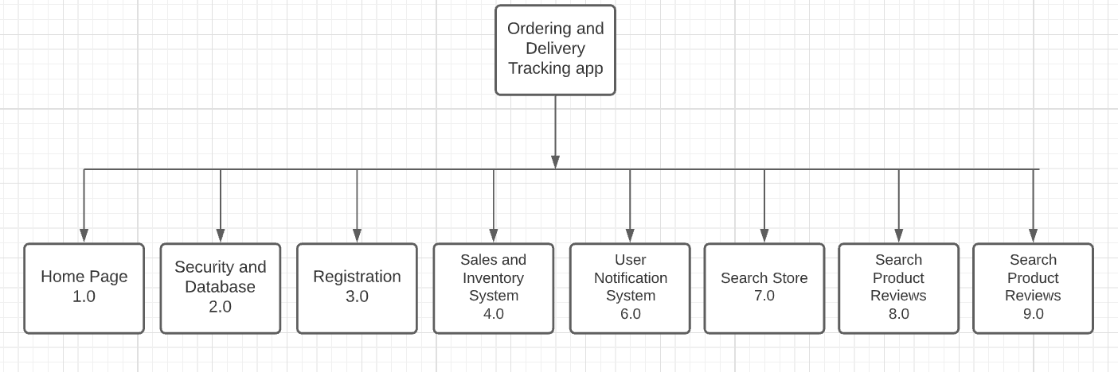

Figure 3.1 HIPO of the App

The app is composed of several components that would build the entire system. Each Customer, Store Owner, Rider, and Administrator app has each of the following of modules. Home Page, Security and Database, Registration, Sales and Inventory System (Store Owner), User Notification System, Search Engines and Full administrator tools. On the Figure above listed all the components for the customer’s app.

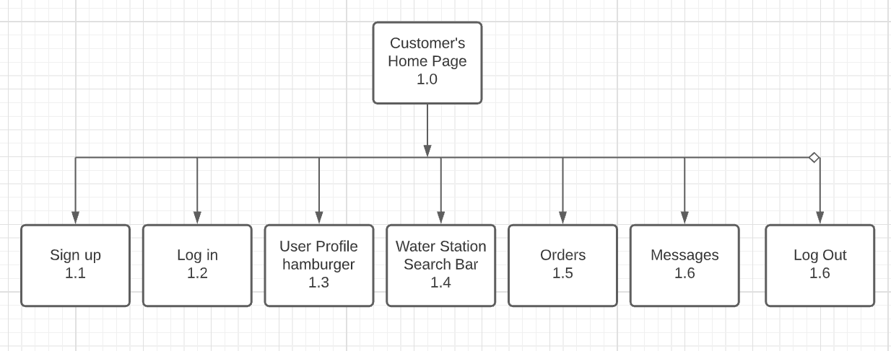

Figure 3.2 Customer’s Home Page

This is the sample HIPO of the Customer’s Home page is composed of useful and friendly UI for the customer. For the new customer they have to sign up, and that is where sign up button is for. Once profile has been created, he can log in in Log In button provided on the interface. Customers can also modify their profile information in User Profile hamburger tab, in this section they can modify or update their information that they used in signing up. One of the functions of this app is a feature of searching water stations and this is provided by the Water Station Search Bar, this can be found on the top of the screen. When they use the search bar the panel will provide them a UI or a Map for the location of the water station. They can tap on the icon and it will provide them an option to call or place an order with a User Interface tab. In Orders tab. Here customers can see their recent orders, they can also check the current status of the order and they have an option to cancel the order when they needed to. Messages tab is for notifications, this includes message order status and an order confirmation messages.
System Architecture
The proponents have identified what would be the best structure for the system. In this figure you can see the ideal system architecture, the system mainly has 4 types of users. Customers, Store Owner (Owner/Partners), Driver (Rider) and the Admin (Administrator/Developers)
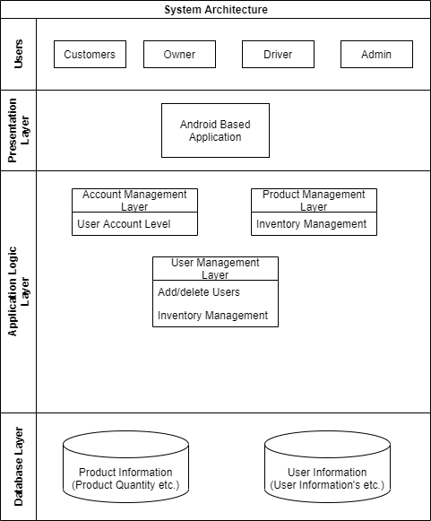
Figure 3.3 System Architecture of the System
All of the users will be using an android based application to their phones that can be connected through the internet, requests coming from the Users are being processed in application layers and servers. Since the server is Firebase the proponents would use its built-in cloud services like database. Authentication services and data and database management. The proponents will be using firebase plug-ins for the system.
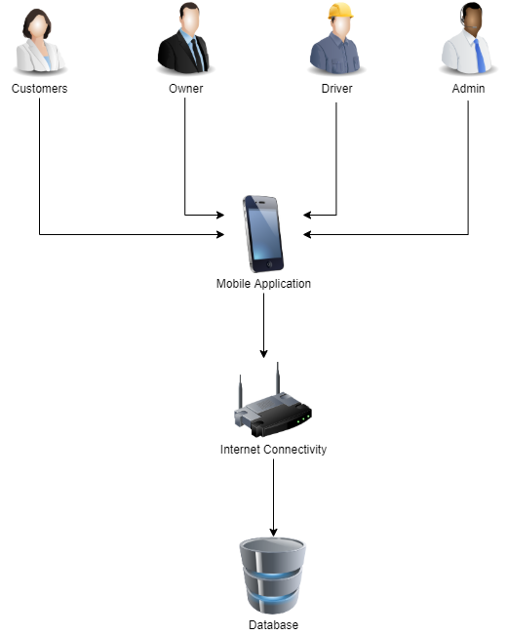
Figure 3.4 System Architecture for the System
Conceptual Framework
This section will represent the application as a conceptual entity-relationship model. The proponents defined conceptual design is required to discuss all needed data that acquired throughout the study and to prove that it supports all processes in the required specifications.
INPUT
Information & Knowledge Requirements
GPS
Java/Kotlin
Firebase
Software Requirements
Android Studio
Hardware Requirements
Device running Android marshmallow or above

INPUT

Problem Definition
System Design
System Development
Testing
Evaluation
Implementation
OUTPUT

Ordering and Delivery Tracker App for Quadro King Water Station Retail Store

Figure 3.5 Conceptual Design

We can see here in this section the technology used in the system. Android app development requires knowledge in the integration of Global Positioning System, the language for the system is written in either Kotlin or Java or can be both. The proponents used the most popular Interface Development Environment which is Android studio. The proponents strongly encourage to use this IDE in android development because it has lots of tools and sources available in the community and Stack Overflow.
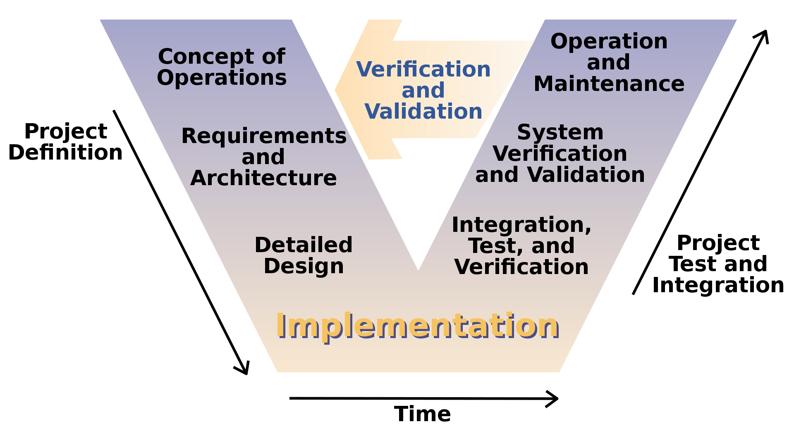
Figure 3.6 V-Model
In designing the project, we will undergo through phases of the study and will be represented in the V-model conceptual Design (Software Development). The early stages of the development should define the project and its goals for the users. In this part the proponents formulate the concept of Operations, the proponents should define what are the modules needed in order to construct the system. Concept of operations should be able to define the main goals of the software development, after that the proponents will be able to define what technology and design the architecture of the system, this will include the programming languages used, what systems services will be implemented and learn how to use them, integrate locations tracker (GPS) in the system since this is one of the main functions of the system. In Designing Phase, the proponents, after studying and gathering the requirements should be able to conceptualize the system design that would be the framework for all throughout of the system. The proponents will take advantage of designing and prototyping applications like Figma, and Adobe Suites. In designing the application, the proponents will have to make sure that the aesthetics are not being set aside. This is to make sure that the app will provide ease of use to the users without compromising the functionalities. After this phase, the proponents planned to implement the system in real world situation and would get feedback from the users about their overall application usage experiences. This will be gathered through a quick survey that is also integrated in the app’s feature. Upon gathering the data from the users, developers should check the integrity of the data and verify how will it provide a better design and functionalities. The developers shall conduct test tot define if the gathered data is contributing to the development of the system. Bugs, glitches and some software errors will be also be fixed once the integration test is done. System Verification and validation, in this phased the developers shall ensure that the fixes and modification they made in the app has been successfully integrated with the app after conducting series of test and will formulate plans to maintain procure additional system needs in the app. After the Project Test Integration Phase, the operation will cycle through the first phase which is the designing phase. This is how developers should be able to modify and make changes to the app with the consideration of all gathered information in Project Test Integration Phase.

Cost Benefits Analysis
This section estimates the cost of the software, hardware and labor required by the application of the project. It should also demonstrate the values added to a given institution by the application of the project. The proposed application only needs a working android phone that has an android version of Kitkat or newer.

I. Hardware Cost
This is optional, if the rider or the delivery person does not have and
android phone or it does not meet the required specifications to run the application.

Specifications | Quantity | Unit Price | Cost
realme c11 | 1 | 4,990 | 4,990
Total: 4,990
Table 3.1 Hardware Cost
Source: www.Lazada.com.ph
II. Software Development Cost
Personnel | No. of Personnel | Salary
Programmer | 1 | 20,000
System Analyst | 1 | 27,000
Total:47,000
Table 3.2 Software Development Cost
Source: www.jobstreet.com.ph
Personnel Salary for 60 days:
Programmer: 20,000 / 60 = PHP 333.33
System Analyst: 27,000 / 60 = PHP 450
III. Operational Cost

- System Cost
Items | Specification | Cost
Front / Back End | Android Studio | Free
Database Hosting | Firebase | 533.65 / month (Small Level)
TOTAL:533.65 (MONTHLY)
Table 3.3 System Cost

Source: www.firebase.google.com

- Utility Expenses
Particulars | Cost
Electricity | 6,000
Total: 6,000
Table 3.4 Utility Expense
Computer usage PHP 100 per day for 10 hours in 60 days

Source: www.meralco.com.ph
- Training Cost
Personnel | Amount per day | Days | Hours | Total
Administrator | 180 | 3 | 3 | 540
Employee | 180 | 3 | 3 | 540
Total:1,080
Table 3.5 Training Cost
(60 / hour * 3hours) * 3 days = PHP540

IV. Summary Cost
Cost | Amount
Hardware Cost | 4,990
Software Development Cost | 47,000
System Cost | 533.65
Utility Expense | 6,000
Training Cost | 1,080
TOTAL: 59,603.65
Table 3.6 Summary Cost
Estimated Benefits:
Accuracy and efficiency of the software at 85%

Total estimated benefits = 59,603.65 * 85%

Total = PHP 50,662.55
Payback Period:
Payback period = (Total Cost / Total estimated benefits) * 12

= (59,603.65 / 50,662.55) * 12

Total = 14 months or 1 year and 2 months
Return of Investment:
Return of investment = (Total estimated benefits / Total Cost) * 100

= (50,662.55 / 59,603.65) * 100

Total = 85%

Requirements Analysis

In this section, the proponents must determine information requirements with regard to the current working system when ordering water in the community. The system involves the consumers (customer who orders water), (Drinking Water Refilling Stations), Delivery Personnel (Rider/ The one who take the product to the customer’s location). The current system working in Metro Manila is where the customer calls or go to the shop to order the water container by providing the shopkeeper their address and then a delivery person delivers the order to the customer’s house. This current system has a lot of disadvantages. The major disadvantages of this offline system are repeated calls from the customer and to customer, if multiple orders are placed at the same area the delivery person has to travel multiple times, and there is no order tracing and there is a direct contact from delivery person to customer. Customers’ are also at risk of infection if they have to go outside of their homes to order water containers.

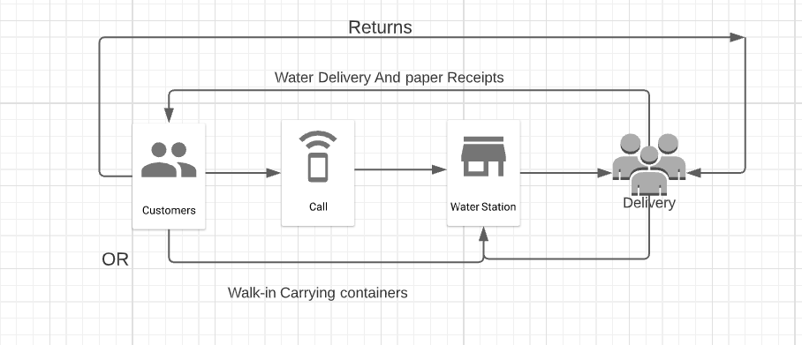
Figure 3.7 Current Water Ordering System

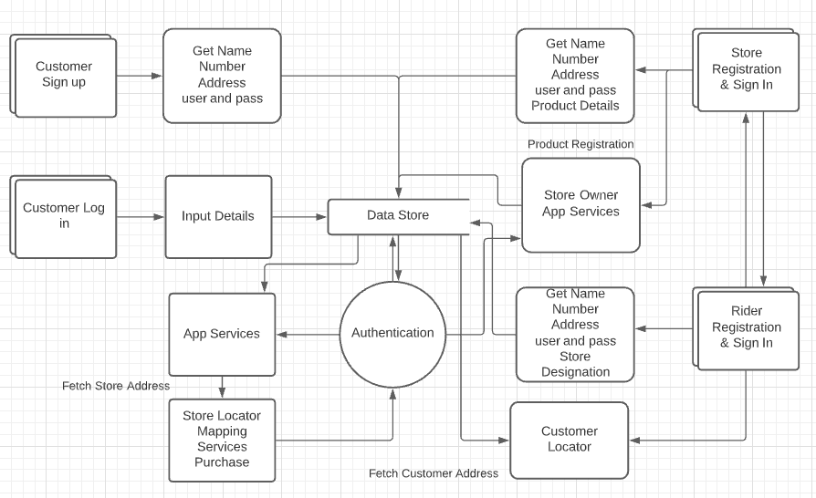
Figure 3.8 Dataflow Diagram of the proposed system

The Dataflow Diagram of the proposed system can be use to show more detailed view of the architecture of the processing system. This shows the design where the customer choose to sign in and use the appthe app will ask for customer details such as Name, Address, user-id and password and it then send and store this to the database. Once done when they choose to log in into the App they have to input User-Id and Password details and will be authenticated through Firebase Authenticator, once security pass the customer can use the app services such as store locator where this will fetch information from the database and this will be authenticated. Store owners upon successful registration they can mange their products in the system they can either add product, modify and set price tags then this will be stored in the database this will also be showned if the customer wishes to purchases a product.

